Match the picture and the invention with the inventor.

1. 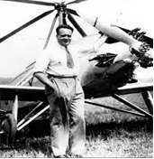 Helicopter
2. Carles Buigas
3. Fructuós Gelabert
4. Juan de la Cierva
5. Narcís Monturiol i Estarriol

Answer: c

1. 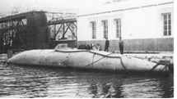 Submarine
2. Blasco de Garay
3. Isaac Peral
4. Alejandro Goicoechea
5. Carles Buigas

Answer: b

1. 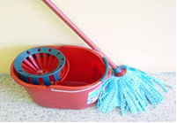 The mop
2. Manuel Jalón Corominas
3. Jerónimo de Ayanz y Beaumont
4. Emilio Bellvis Montesano
5. Celedonio Calatayud

Answer: a

1. 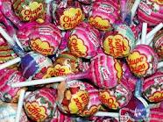 Chupa Chups/Lollipops
2. Enric Bernat
3. Alexandre de Fisterra
4. Emilio Bellvis Montesano
5. Juan José Lerena y Barry

Answer: a

1. 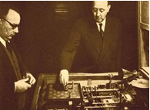 Automaton
2. Diogo Ribeiro
3. Juan Roget
4. Leonardo Torres Quevedo
5. Blasco de Garay

Answer: c